**Proposed Project**: To create a Chill Out app that includes calming images, guided breathing, positive affirmations, and soothing music. The initial screen will allow you choose the options, then renders the screen based on the options chosen.

**Target Audience:** In general,Kids (or adults) who are feeling stressed, anxious, or upset and could use a few minutes of peace and calm to help regulate their emotions and lead to an increased sense of control and calm. Specifically, my kids. I have one child who struggles with generalized anxiety disorder that sometimes leads to panic attacks and another with ADHD. They both use a variety of calming techniques for different reasons and I’m hoping this app will be useful to both of them.

**Logo:**



**Data Sources:** Affirmations API (<https://www.affirmations.dev/>), Canvas API

**Modules:**

Select_options

Draw_shapes (using CSS animation)

Get_affirmations (from Affirmations API)

Guided_breathing

**Wireframes:**

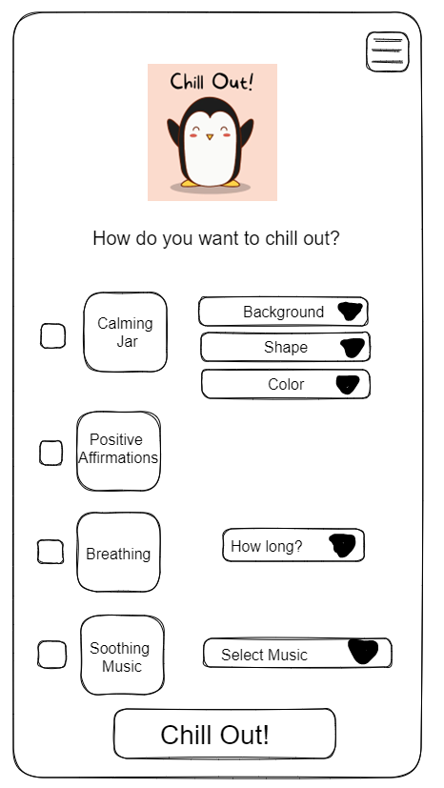

The main screen will allow you choose the components that you want to display – you can choose any combination. I want to code it so that the options for each component will only display when the check box is checked. When you click the “chill out” button, the screen will render with whichever options you’ve chosen.

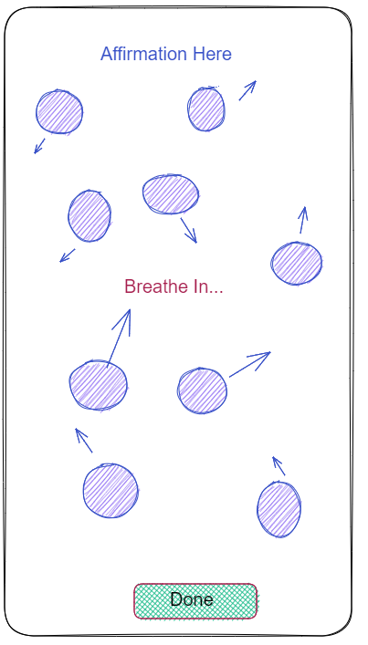

This is an example of what the rendered screen might look like. The chosen shapes will move slowly around the screen. The affirmations will display on a set timer. For the breathing cues, “Breathe in…” will slowly grow in size over the course of about 5 seconds, then change to “Breathe out…” in a different color and slowly decrease in size. When the done button is clicked, the app will return to the main screen.

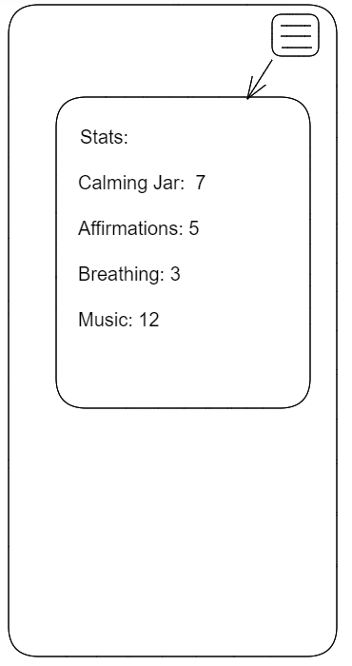

Accessing the hamburger menu from the main screen will show the number of times each component has been chosen – these values will be stored in localStorage. Since I’m hoping to actually make this an app that my kids will be able to use, this will give me the data I need to make adjustments in the future – such as removing components that they don’t use and adding new ones.

**Development Time Line:**

Week 10: build interface, start calming jar basic coding

Weeks 11-12: add background, shape, and color functionality to calming jar

Weeks 12-13: add affirmations, breathing, and soothing music functionality

Weeks 13: finish any remaining programming, testing, debugging

Week 14: complete & submit